**Automating New Service Account(s)**

**Service desk Information**

**New Service Account(s) Configuration Item Detail**

|  |  |
| --- | --- |
| Attribute Name | Value |
| Name | New Service Account(s) |
| class | [**Application Security**](javascript:showDetailWithPersid(%22grc:400102%22)) |
| family | Security |
| Active? | Active |
| Host Name | Multi Orderable |
| Alt CI ID | New Service Account(s) |
| Asset? | NO |
| CI? | YES |
| Description | This is to request a new Service Account in Active Directory Users and Computers (ADUC). |
| Primary Contact | [**Identity Operations**](javascript:showDetailWithPersid(%22cnt:8BBFEC936F7F7F43878B0B6F7F721FFF%22)) |
| Request Group | [**Identity Operations**](javascript:showDetailWithPersid(%22cnt:8BBFEC936F7F7F43878B0B6F7F721FFF%22)) |
| Service Level Access | X |
| Process Path | /Identity Management/Send Form |
| Service Status | Production |
| Icon Path | \\catalog\Icons\AdminUser.png |

Catalog Table

|  |  |
| --- | --- |
| Attribute Name | Value |
| CATALOG_ID | 214286 |
| ENTITY_TYPE | Entitlement |
| ENTITY_KEY | 181788 |
| PARENT_ENTITY_TYPE | ApplicationInstance |
| PARENT_ENTITY_KEY | 90 |
| ENTITY_DISPLAY_NAME | New Service Account(s) |
| ENTITY_NAME | 113~New Service Account(s) |
| ENTITY_DESCRIPTION | This is to request a new Service Account in Active Directory Users and Computers (ADUC). |
| IS_REQUESTABLE | 1 |
| IS_DELETED | 0 |
| USER_DEFINED_TAGS | Multi Orderable |
| TAGS | Multi Orderable 113~New Service Account(s) New Service Account(s) Application Access PH Active Directory Connector Server ApplicationAccess Application Access |
| CATEGORY | Entitlement |
| AUDIT_OBJECTIVE | (Null) |
| APPROVER_USER | (Null) |
| APPROVER_ROLE | (Null) |
| FULFILLMENT_USER | (Null) |
| FULFILLMENT_ROLE | (Null) |
| CERTIFIER_USER | (Null) |
| CERTIFIER_ROLE | (Null) |
| ITEM_RISK | 3 |
| CERTIFIABLE | 1 |
| RISK_UPDATE_DATE | 19-JAN-19 03.16.23.000000000 AM |
| CATALOG_CREATEBY | 4 |
| CATALOG_CREATE | 19-JAN-19 |
| CATALOG_UPDATE | 26-NOV-19 |
| CATALOG_UPDATEBY | 4 |
| IS_AUDITABLE | 0 |
| CONTACT_NAME | Identity Operations |
| UDF_CATEGORY | Multi Orderable |
| PRODUCT_VERSION | (null) |
| IS_ASSET | 0 |
| IS_CI | 1 |
| LICENSED_TYPE | Application Security |
| IS_ITCM | 0 |
| FAMILY_NAME | Security |
| FULFILL_GRP | Identity Operations |
| FULFILL_GRP_UUID | 8BBFEC936F7F7F43878B0B6F7F721FFF |
| SEC_APPROVER_GRP | (null) |
| SEC_APPROVER_EMAIL | (null) |
| IS_APPRGROUP | (null) |
| SEC_APPROVER_GRP_UUID | (null) |
| LOCATION_NAME | (null) |
| UDF_COST_CENTER | (null) |
| UDF_API_ROLENAME | (null) |
| PRODUCTION_STATUS | Current |
| PRICE | (null) |
| ASSET_MODEL | (null) |
| IS_PAM | 1 |
| IS_SD | 1 |
| IS_CMDB | 1 |
| ENTITY_UUID | 1834793E287CB54CBE06FB23F5440E80 |
| AD_GROUPS | (null) |
| ICON_PATH | https://catalog/usm/FileStore/icons/AdminUser.png |
| PAM_PROCESS_PATH | /Identity Management/Send Form |
| UDF_ENTNAME | New Service Account(s) |

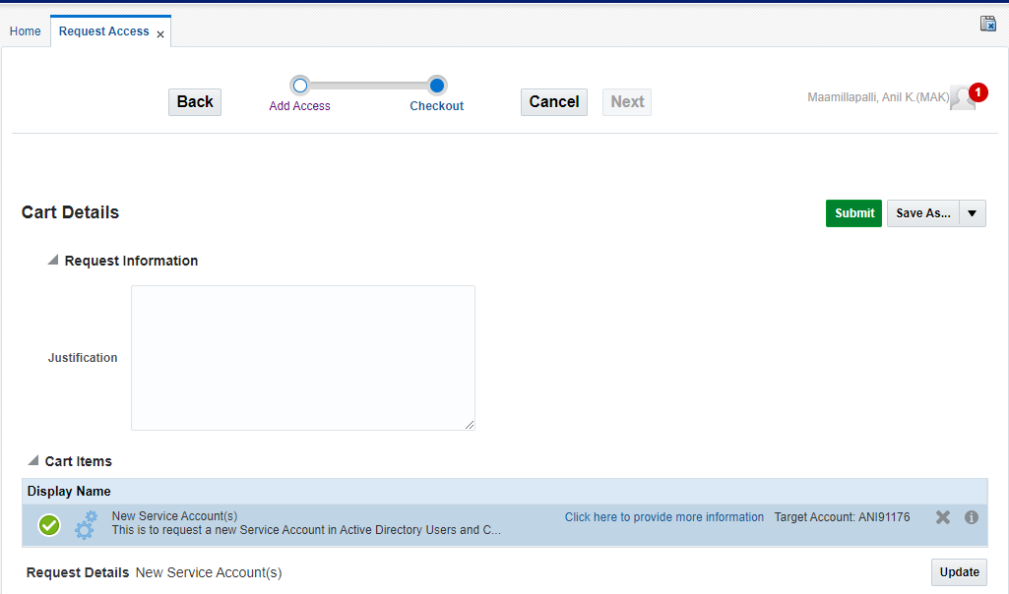

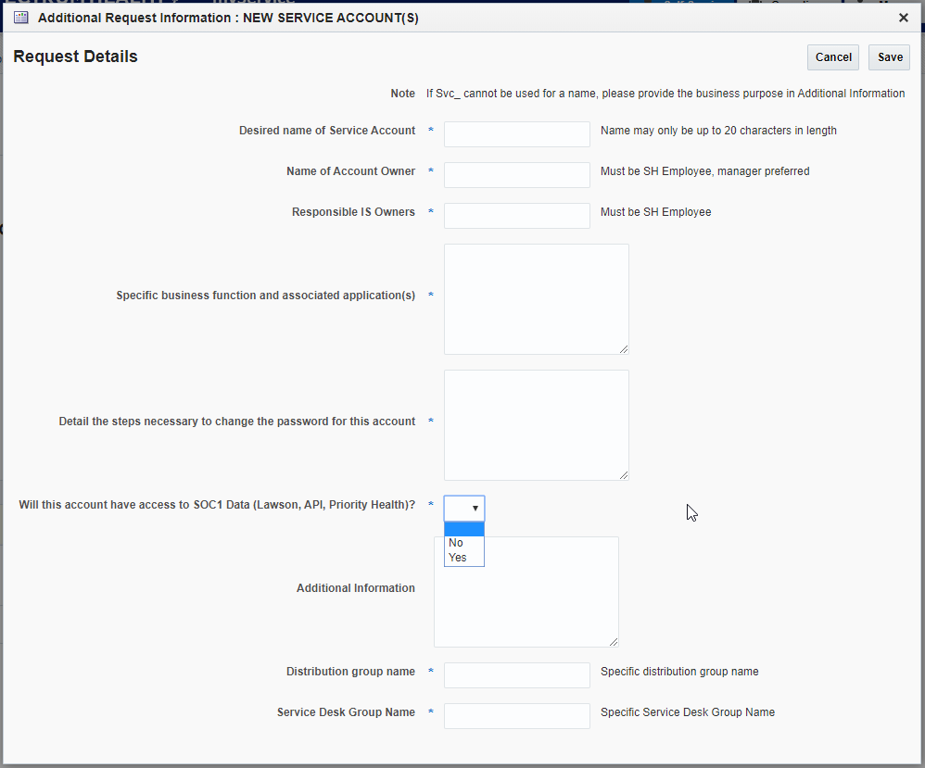

Branchmaster

Branch actions

[SH_IAM_PhaseII_Codebase](https://bitbucket.spectrum-health.org:7991/stash/projects/SD/repos/sh_iam_phaseii_codebase/browse)/[src](https://bitbucket.spectrum-health.org:7991/stash/projects/SD/repos/sh_iam_phaseii_codebase/browse/src)/[org](https://bitbucket.spectrum-health.org:7991/stash/projects/SD/repos/sh_iam_phaseii_codebase/browse/src/org)/[sh](https://bitbucket.spectrum-health.org:7991/stash/projects/SD/repos/sh_iam_phaseii_codebase/browse/src/org/sh)/[oim](https://bitbucket.spectrum-health.org:7991/stash/projects/SD/repos/sh_iam_phaseii_codebase/browse/src/org/sh/oim)/[adapters](https://bitbucket.spectrum-health.org:7991/stash/projects/SD/repos/sh_iam_phaseii_codebase/browse/src/org/sh/oim/adapters)/[constants](https://bitbucket.spectrum-health.org:7991/stash/projects/SD/repos/sh_iam_phaseii_codebase/browse/src/org/sh/oim/adapters/constants)/**CatalogAdaptersConstant.java**

